5 Foot & 2 ½ Foot Stainless Steel Grills with or without Hood (Magicator TM)
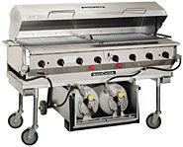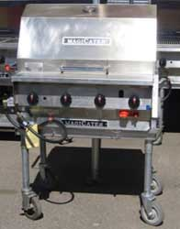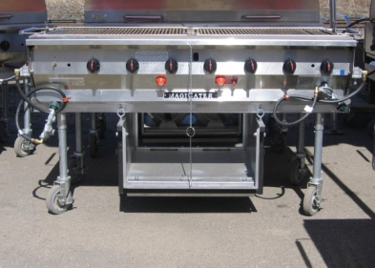
Operating Instructions
The following instructions will help you recall the personal instructions given to you by your rental center.
- Insure that the propane tank is in the proper position.
- Attach the 40 lb propane tank to the grill regulator.
- Open the cooking hood, if so equipped.
- Turn all the burner knobs and red or black runner tube knobs clockwise to the “off” position.
- Slowly open the valve on propane tank.
- Push and turn the runner tube knobs fully counter-clockwise to the “on” position. Insert a lit fireplace match or fireplace lighter through the oblong hole in the front panel.
- Check that the entire runner tube is lit by looking through the sight hole(s) located between the last two burner knobs on the front panel.
- After lighting the runner tube(s), open the desired burner valves and observe that the burners light completely.
Shutdown Instructions
- Turn off the burner valves.
- Close the propane tank valve.
- Turn off the runner valves.
- Detach the propane tank from the grill.
Cleaning Instructions
- Remove excess food stuff from grill.
- Cooking Top Grids: After cooling remove the cooking top grid, use warm soapy water and a stiff bristled brush or plastic pad. The cooking grid must be removed to steam clean or pressure wash. Do not use steel wool or abrasive pads as they may degrade the metal finish.
- Radiants/Covers: These will need little or no cleaning due to high in-use temperatures. If necessary, clean as for the cooking grid.
- Frame Assembly: Use warm soapy water and a stiff bristle brush or plastic pad. Be careful not to get water into the burners or runner tubes. DO NOT pressure wash.
- Water Tubs: Clean as per top grids.
Trouble Shooting
- If all of the valves are not closed or if the propane tank valve is opened too quickly the regulator excess flow valve may restrict the flow of gas and the grill will not light or will have very small flames. If the excess flow valve restricts the flow of gas shut off all of the valves, disconnect the propane tanks, wait five (5) minutes, and then re-connect the tanks and follow the instructions above.
- If the runner tube(s) will not light or stay lit, shut off the gas supply and wait five (5) minutes before attempting to re-light the unit.
- If the burners fail to light or remain lit, shut off the gas valve and disconnect the gas supply tank(s) and wait five (5) minutes to re-connect the tanks and re-light the grill.
- If a burner goes out, shut off the gas valve immediately and allow the gas to dissipate for at least five (5) minutes before re-lighting.
Safety Precautions
- Use extreme caution in handling and using propane gas. Gas allowed to escape can result in a fire or explosion. It is heavier than air and may settle in the fire box or on the floor.
- Permit only competent persons to operate grill.
- DO NOT use the valve on the propane tank to control the gas flow to the grill.
- DO NOT leave the grill unattended while operating.
- Check periodically to insure that all the burners are ignited.
- DO NOT use any adapters to connect different propane tanks and or other forms of gas to the grill.
- This grill is intended for outdoor use. DO NOT operate the grill in a confined space without adequate ventilation. If air does not circulate, use a fan to exhaust air through window or other opening.
- If the tank valves are not opened slowly the excess flow valve in the regulator (a safety feature) may restrict the flow of gas to the unit resulting in little or no flame at the burners or runners. Should this happen, follow the shutdown instructions and be sure to shut off the tank(s) and remove and re-attach the tank(s) connectors as instructed. This is necessary to re-set a closed excess flow valve. Repeat the lighting instructions. The appliance should now function normally. Failure to follow these guidelines may cause the excess flow valve to restrict gas flow.

