Belgian Waffle Maker Instructions
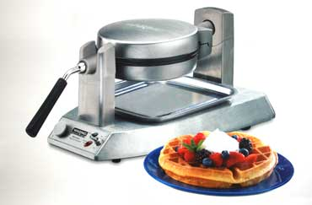
Instructions copied from Manufacturers brochure

If a long extension cord is used, the marked electrical rating of the extension cord should be at least as great as the electrical rating of the appliance, and the longer cord should be arranged so that it will not drape over the countertop or tabletop where it can be pulled on by children or animals, or tripped over.
INSTRUCTIONS FOR USE
- Before using your WaringTM Commercial Belgian Waffle Make for the first time, remove any dust from the shipping by wiping the plates with a damp cloth. Remove all protective paper and wrapping.
- Plug cord into 120V AC wall or outlet.
Switch the toggle switch to the “ON” position. The “RED” light will go on to signal power. The waffle make will now begin the preheating process. This should take about 4 minutes. The waffle maker will sound 6 beeps and the “GREEN” indicator light will go on to signal the unit is ready for baking. Season the waffle grids by spraying with cooking spray or brushing with a flavorless oil.
For initial use, it is important that the waffle make is preheated before seasoning with cooking spray or oil.
NOTE: the first time you use your waffle maker, it may have a slight odor and may smoke a bit. This is normal, and common to heating appliances.
- Preheat your WaringTM Commercial Belgian Waffle Maker on setting #4 or preferred setting (green indicator light will be illuminated when preheated). For best results, do not open waffle maker during cooking process. Doing so will interfere with the timing mechanism.
- Using the recipes provided (fill measuring scoop to fill line ¾ or to top of measuring scoop depending on the recipe. For loose batters, fill to the ¾ mark; for thicker batters fill to the top) and pour batter evenly into the center of the waffle grids. Use a heat-proof spatula to spread the batter evenly over the grids. Close the lid and rotate the unit 180 degrees to the right.
- When the waffle is completely baked, the waffle maker will sound 3 beeps. Baking time is determined by browning level. Choose a setting on the browning control dial. For golden brown waffles, we recommend using setting #4.
- Once the waffle is ready and the waffle maker has beeped 3 times, rotate the waffle maker 180 degrees to the left, open the lid and remove waffle by gently loosening the edges with a heat-proof plastic spatula. Never use metal utensils, as they may damage the nonstick coating.
- Always disconnect the plug from the wall outlet once baking has been completed.
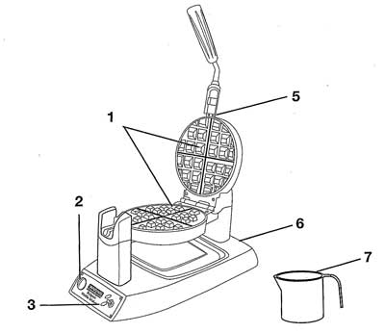

SPECIAL FEATURES:
- Deep ½” Waffle Grids
- Browning Control Adjustment. Adjustable for different batters and personal preference.
- Indicator lights:
  - Red signal indicates waffle maker is in “ON” position
  - Green signal indicates waffle maker is “Ready to Bake”
- Lockdown Lid – will not rise as waffles bake
- Indicator Beeps
  - 6 beeps indicate unit is ready to bake. After the waffle maker has been plugged into electrical outlet and turned to the “ON” position, the waffle maker will beep 6 times, indicating it has reached baking temperature (not shown)
Note: this will only occur for the first waffle of each baking session
  - 3 beeps indicate waffle is done
- Die-cast Housing
- Measuring Scoop

NOTE: This WaringTM Commercial Belgian Waffle Maker has been treated with a special nonstick coating. Before the first use, we suggest you season the waffle grids by brushing with cooking oil. Wipe with a paper towel or pastry brush.

TIPS FOR MAKING PERFECT BELGIAN WAFFLES
We recommend setting #4 when using commercial pancake/waffle mixes.
We recommend setting #4 for Belgian waffle recipes.
If you prefer crisper, darker Belgian waffles, increase the browning control.
For evenly filled waffles, pour the batter into the center of the lower grid and spread out evenly to the edges. The entire lower grid should be filled.
For best results, we recommend using ¾ cup batter or enough to fill the entire lower grid.
For added convenience while baking waffles, rest measuring scoop with handle hanging on outside of bowl and scoop on inside of bowl until the next baking cycle.
To measure flour, stir the flour first to aerate it, since it settles when it sits. Then spoon it into a measuring cup, leveling off the top with the back of a knife – do not pack down into measuring cup. These quick steps will help you avoid “heavy waffles”. Belgian waffles taste best when made to order, but baked Belgian waffles may be kept warm in a 200 degrees Fahrenheit oven. Waffles wrapped in foil may lose their crispness.
Baked waffles may be frozen. Allow to cool completely, and then place in plastic food storage bag. Use waxed paper to keep waffles separated. Reheat in an oven, toaster, or toaster oven when ready to use.

SUGGESTED TOPPINGS

Maple syrup, fruit syrups
Warm fruit compote, fruit sauce
Fresh berries, chopped fruit, chopped nuts
Powdered sugar
Whipped cream, Ice Cream, Sorbet
Chocolate sauce
Fruited yogurt

