Hot Dog Broiler/Rotisserie
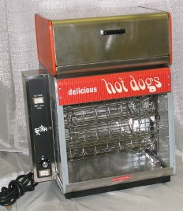

INSTALLATION/OPERATION PROCEDURE

- Place the desired quantity of hot dogs on the holders.
- When ready to start broiling, push the switch to “ON” position and the infinite control switch to “HIGH”. NOTE: A lower infinite control setting may be used for slower broiling.
- The time required to broil the hot dogs will vary, depending upon the size and temperature of the hot dogs when placed in the broiler.

With the switch “ON” and the infinite control on “4½”, average size hot dogs at room temperature will be ready for serving in about 15 minutes. This time can be decreased to 10 minutes by setting the control on “HIGH”, but care should be taken so as not to blister the hot dogs at this setting. Turn control to 2½ or 3 to keep the hot dogs in a ready to serve condition.

Hot dogs can be held for several hours on this unit without loss of flavor or shriveling. For continuous use during rush periods, the units can be left on any setting without harm.

NOTE: When you turn the switch to the “OFF” position, you also turn off the heating element.

- Load or unload the hot dog wheel by pressing in and holding the serve switch to stop the hot dog wheel.
- The hot dog wheel can be removed from the unit for cleaning. The glass is removable for cleaning but care should be exercised when doing so.

UNITS EQUIPPED WITH BUN COMPARTMENT

Put one quart of water in the bun compartment to keep buns moist and warm. Use warm water for best results. Check water level periodically and add water when necessary. Buns will become stale and hard if there is no water in the bun compartment pan.

NOTE: The choice of buns will make a difference in the quality of the heated buns. A bun with a doughy interior is not as good as one with a course makeup.

Hot Dog Roller w/larger spindles: Takes approximately 20 minutes 20 hot dogs.
Hot Dog Steamer: Takes 20-25 minutes. 75 hot dogs-20 buns.
Hot Dog Broiler: Takes the most time, better flavor. Carousel style. A half an hour. 20 hot dogs.

